Experiment 6

Code:

import java.net.*;

public class ip_2 {

public static void main(String[] args) {

try {

InetAddress ip2 = InetAddress.getLocalHost();

System.out.println("Host Name: " + ip2.getHostName());

System.out.println("IP Address: " + ip2.getHostAddress());

}

catch (Exception e) {

System.out.println(e);

}

}

}

Screenshot:

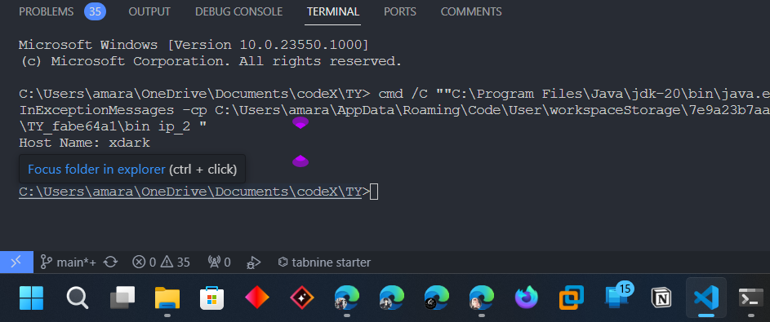

Code:

import java.net.*;

public class ip_1 {

public static void main(String[] args) {

try {

InetAddress ip = InetAddress.getByName("www.youtube");

System.out.println("Host Name: " + ip.getHostName());

System.out.println("IP Address: " + ip.getHostAddress());

} catch (Exception e) {

System.out.println(e);

}

}

}

Screenshot:

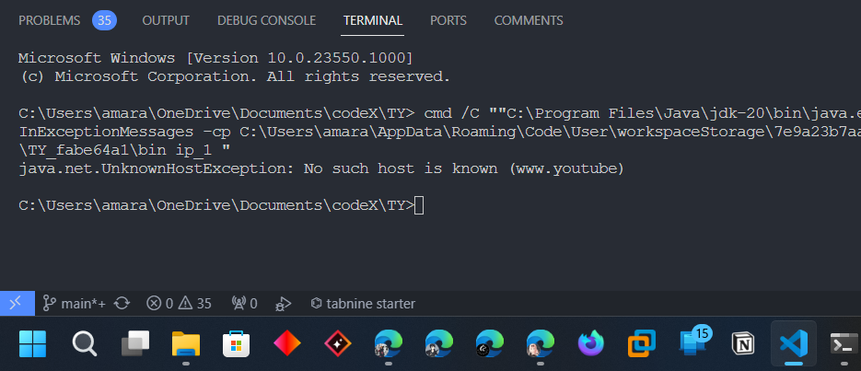

Code:

import java.net.*;

public class ip_3 {

public static void main(String[] args) {

try {

InetAddress ip = InetAddress.getByName("www.youtube.com");

System.out.println("Host Name: " + ip.getHostName());

System.out.println("IP Address: " + ip.getHostAddress());

} catch (Exception e) {

System.out.println(e);

}

}

}

Screenshot:

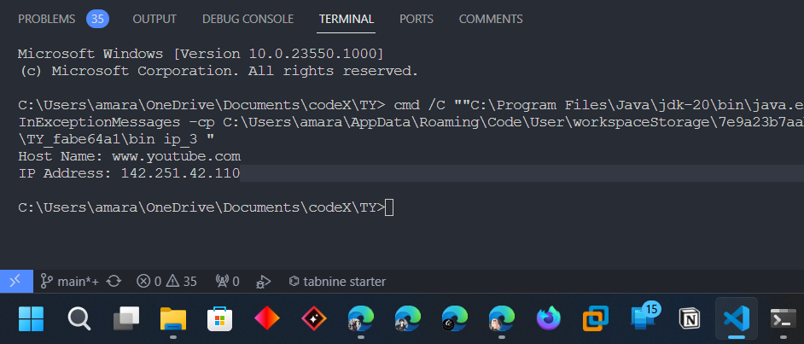

Code:

import java.net.*;

public class ip_4 {

public static void main(String[] args) {

try {

URL url1 = new URL("https://www.geeksforgeeks.org/java/");

// URL url2Url = new URL("http://httpbin.org/");

System.out.println(url1.getProtocol());

System.out.println(url1.getPort());

System.out.println(url1.getDefaultPort());

System.out.println(url1.getFile());

System.out.println(url1.getHost());

System.out.println(url1.getContent());

}

catch (Exception e) {

System.out.println(e);

}

}

}

Screenshot:

